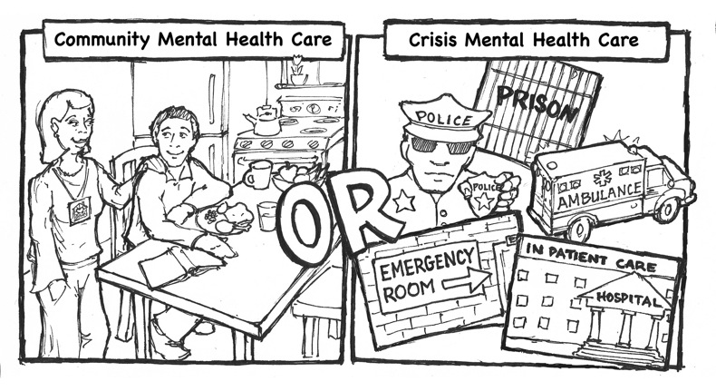

$$ $$$$$$$

$125,000/person/yr $400,000/person/yr

(Fully-staffed supported apt. care) (Long-term in-patient care)

**Gilead Community Services**

2011 – 2012

* 13 Clients Transferred from Long-Term In-patient settings to

Fully staffed supported apartments

* 40 New Jobs
* $3,500,000 Annual Savings to the State